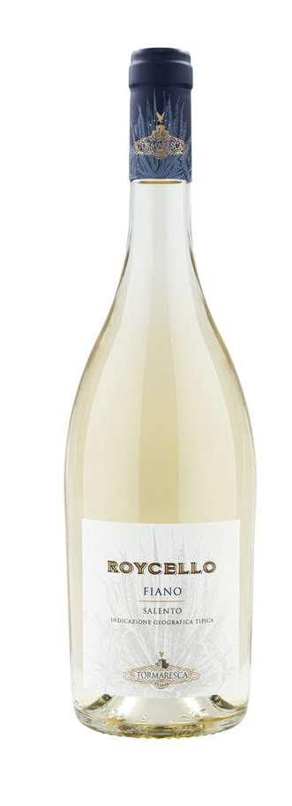
ROYCELLO
Classification
Fiano I.G.T. Salento
Vintage
2024

Grape variety
A selection of Fiano from Tenuta Maìme in S. Pietro Vernotico (BR)

Climate
2024 began with mild winter weather and average levels of rainfall that replenished good groundwater reservoirs in vineyard soils. The growing season was dry, both in spring and summer. Spring temperatures were consistent with seasonal averages, while summer saw higher temperatures but without any extreme heat events. Breezy condition and the beneficial influence from the Adriatic Sea brought good temperature swings between day and night that helped preserve the grape variety’s aromas and freshness.
Attentive soil management practices together with careful canopy management kept good air circulation around the grapes and avoided overexposure to sunlight, resulting in an optimal balance in vegetative growth and crop load during summer.
Fiano grapes for Roycello were harvested on September 6th, about one week earlier than average compared to past vintages.

Vinification and aging
The harvest took place once the grapes achieved full aromatic ripeness. Grapes were brought to the cellar, destemmed, and gently pressed. The must was chilled to a temperature of 10 °C (50 °F) for approximately 24 hours to favor natural settling and clarification. Alcoholic fermentation took place in temperature controlled stainless steel tanks at a temperature of 16 °C (61 °F). The wine was left to age on the lees in stainless steel for about 4 months then bottled.

Alcohol content
12.5% by Vol.

Historical data
Masseria Maìme is located in one of the most beautiful areas of Upper Salento not too far from the town of San Pietro Vernotico in the province of Brindisi. The estate extends along the coastline forming a unique countryside of vineyards that lies between woodlands and pine forests stretching out as far as the eye can see until blending into the sea. The most prevalent grape varieties grown here are Negroamaro, Primitivo, Chardonnay, and Fiano.
There are two neighboring plots on the Masseria Maìme estate: one called Roy and the smaller one, Roycello. These names are a reminder of one the area’s natural inhabitants in the 30’s and 40’s, a Eurasian crane that preferred the swampy area of the Cerano Woods and whose name in dialect mimicked the name Roy. Roycello is produced from the eponymous plot and reflects in both name and style its close connection to the territory.

Tasting notes
Roycello is straw yellow with light green hues. On the nose, enticing notes of white pulp fruit, pineapples, peaches and pears meet citrusy hints of limes and grapefruits. The bouquet is completed by delicate floral aromas of jasmine. The palate is pleasant with outstanding freshness and remarkable sapidity.

