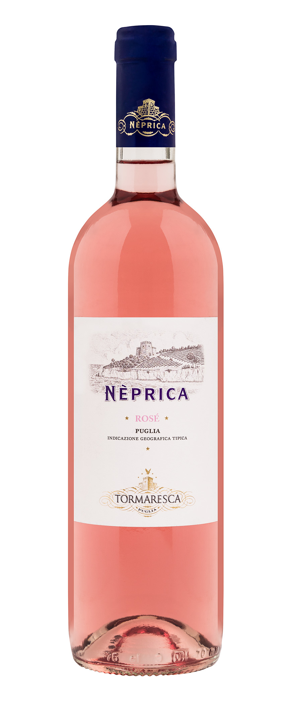
NePriCa Rosé
Classification
Rosato IGT Puglia
Vintage
2024
Climate
Overall, the 2024 growing season in Apulia can best be described as hot and dry. Winter weather was mild and rainy, which brought good groundwater resources to vineyard soils. On the other hand, the vegetative season was quite dry with mild conditions in spring and hot temperatures in summer. Breezy condition and the beneficial influence from the Adriatic Sea brought good temperature swings between day and night that helped preserve aromas and freshness of both white and red grape varieties.
Attentive soil management practices together with careful canopy management kept good air circulation around the grapes and avoided overexposure to sunlight, resulting in an optimal balance in vegetative growth and crop load during summer.

Vinification and aging
Freshly harvested grapes were brought to the cellar, destemmed, and delicately pressed. The free run juice was transferred into stainless steel vats at a controlled temperature of 10 °C (50 °F) to favor natural clarification of the must. Alcoholic fermentation took place at a controlled temperature of 16-17 °C (61-63 °F) to preserve primary aromas. The wine aged in stainless steel vats for a brief period before being released.

Alcohol content
12.5 % by Vol.

Historical data
Viticulture in Apulia is history and at the same time innovation. The Tormaresca estate is the expression of these two spirits. Character, personality, and the potential for high quality are the characteristics that the Apulian territory imparts to all varieties grown here indigenous, or not. The Antinori family started investing in the area in 1998 as they believed that this is one of the most promising regions in Italy for producing top quality wines with a strong territorial identity. Tormaresca has two estates located in the most highly regarded areas for the production of high-quality wines: Tenuta Bocca di Lupo, in the heart of the Castel Del Monte DOC appellation; and Masseria Maìme in one of the most beautiful areas of Upper Salento.

Tasting notes
NePriCa Rosé is a pale peach blossom color. The nose offers fresh notes of citrus fruit and pineapples in perfect harmony with floral hints of jasmine and lavender. The wine is pleasantly fresh and savory on the palate.

