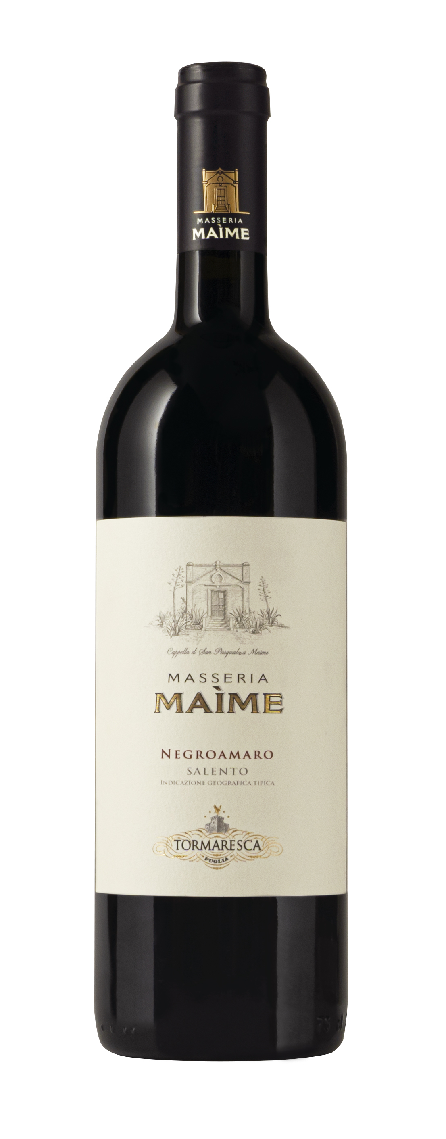
MASSERIA MAÌME
Classification
Negroamaro I.G.T. Salento
Vintage
2023
Grape variety
Negroamaro
Climate
The 2023 growing season saw predominantly mild and rainy conditions during winter and spring. Rain showers in spring caused a delay in the vines’ vegetative cycle, which lasted up to the grape harvest. Flowering occurred 10 days later than seasonal averages. The following summer months were dry without any critical rain events. Good balance between vegetative vigor and fruit load was essential to guarantee that grapes achieved optimal ripening in Tormaresca’s vineyards, also the result of diligent soil management that preserved soil moisture accumulated during winter and spring. The months of August and September were sunny and dry with optimal temperature swings between day and night. Such conditions prompted a late harvest and produced wines with floral notes and a lower alcohol content.
The grape harvest at Masseria Maìme took place on October 12th and 13th, about 2 weeks later than seasonal averages.

Vinification and aging
The grapes were delicately crushed and transferred into stainless steel vats where alcoholic fermentation occurred at a controlled temperature of 26-28 °C (79-82 °F). Gentle pump overs and délestage (rack and return) were performed during maceration on the skins for a gradual, balanced extraction of color, flavor, and aromatic compounds, which extended over a period of 15-18 days. The wine was aged for approximately 11 months, 70% went into 500 liter-capacity tonneaux and the remaining 30% in French oak barriques.

Alcohol content
13.5% by Vol.

Historical data
The Masseria Maìme estate is located in one of the most beautiful areas of Upper Salento not too far from the town of San Pietro Vernotico in the province of Brindisi. The estate extends along the coastline forming a unique countryside of vineyards that lies between woodlands and pine forests stretching out as far as the eye can see until blending into the sea. The most prevalent grape varieties grown here are Negroamaro, Primitivo, Chardonnay and Fiano.

Tasting notes
Masseria Maìme 2023 is ruby red in color. The nose is complex, opening with fruity notes of sour cherries, blackberries and pleasant hints of dried roses and closing with light notes of licorice, black tea and cloves. Entry on the palate is supple and is sustained by elegant tannins and a well-balanced finish.

