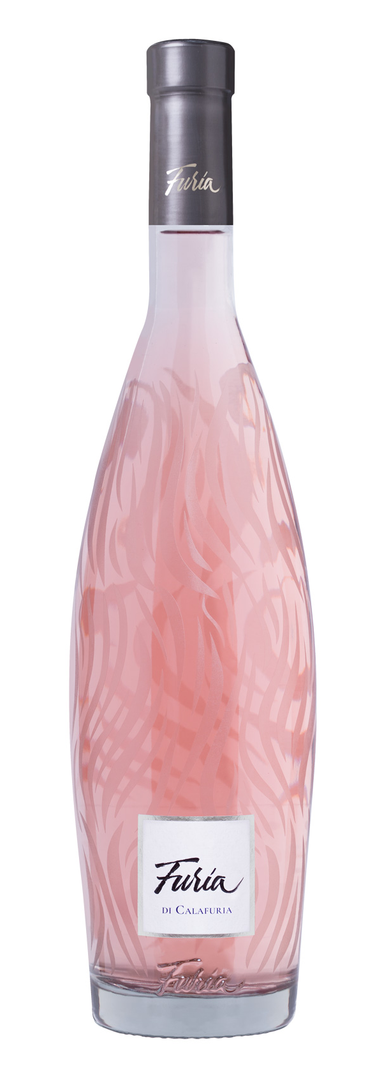
FURIA DI CALAFURIA

Classification
Rosato I.G.T. Salento

Vintage
2024
Grape variety
Negroamaro, Syrah and Cabernet Franc
Climate
Mild winter weather and average levels of precipitation marked the beginning of the 2024 growing season, replenishing generous groundwater reserves in vineyard soils. Overall, the vegetative season was dry, both in spring and summer; spring brought normal temperatures, and summer was hot yet uninterrupted by extreme heat events. Breezy conditions and the beneficial influence from the Adriatic Sea provided excellent temperature swings between day and night preserving the grapes’ unique aromas and freshness.
Careful soil management techniques together with precise canopy management, which kept good air circulation around the fruit without overexposing to sunlight, ensured optimal balance between vegetative growth and crop load during the summer months.
Grapes for Furia were picked earlier than past seasons, the grape harvest began on August 23rd with Syrah and continued one week later with Negroamaro and Cabernet Franc.

Vinification and aging
Each grape variety was hand harvested separately, destemmed, and gently pressed. The must was chilled to a controlled temperature of 12 °C (54 °F) to allow for natural clarification and then transferred to stainless steel vats where alcoholic fermentation took place at a constant temperature of 16 °C (61 °F) to preserve and enhance aromatic compounds of each grape variety. After several months of aging on the lees in stainless steel vats, and after careful tastings, the various lots were blended. The wine was then bottled and later released for sale.

Alcohol content
12.5% by Vol.

Historical data
Masseria Maìme is located in one of the most beautiful areas of Upper Salento not too far from the town of San Pietro Vernotico in the province of Brindisi. The estate extends along the coastline forming a unique countryside of vineyards that lies between woodlands and pine forests stretching out as far as the eye can see until blending into the sea. The most prevalent grape varieties grown here are Negroamaro, Primitivo, Chardonnay and Fiano.
Furia di Calafuria was crafted to celebrate the refined and excellent quality of Apulian rosé wines. The name Furia (fury in English) is a reference to the energy and beauty of natural elements; its extraordinary spirit is elegant and graceful; the wine expresses a perfect balance of its contrasting elements.

Tasting notes
Furia di Calafuria is a lively peach blossom pink color. The nose is inviting and complex with notes of peaches, grapefruits, pineapples and passion fruit accompanied by floral hints of jasmine. The palate is pleasantly fresh, savory with a refreshing citrusy finish.

