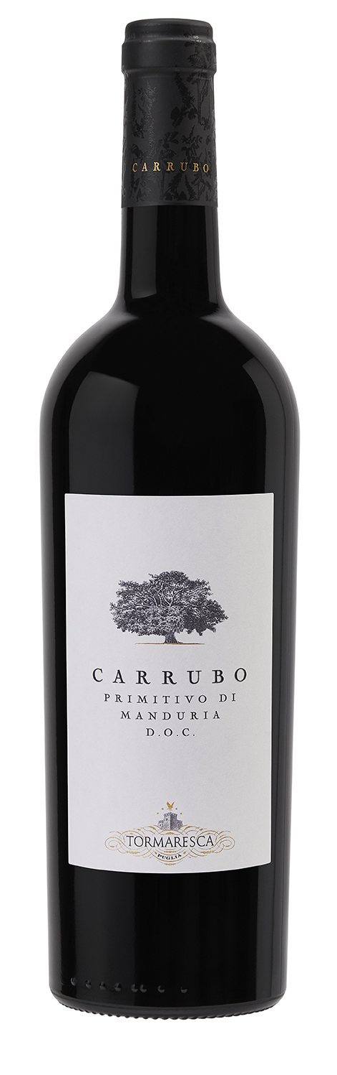
CARRUBO
Classification
Primitivo di Manduria DOC
Vintage
2020
Grape variety
Primitivo
Climate
The 2020 growing season in Salento was dry with typical weather conditions. The winter months were mild with average levels of precipitation followed by a cool, dry spring season.
Normal summer weather brought sunny skies and moderate breezes with significant temperature swings between day and night right before harvest time.
Primitivo grapes achieved ideal skin ripeness with remarkable concentration while preserving the clean pure notes of the fruit. The grape harvest for Carrubo took place between the 17th and 23rd of September, about 10 days later than seasonal averages.

Vinification and aging
The grapes were harvested slightly over-ripe, destemmed and gently crushed. The must was transferred into stainless steel vats where alcoholic fermentation took place at a controlled temperature of 27 °C (80 °F). Gentle pump overs during maceration on the skins, which lasted for a period of about two weeks, ensured the extraction of only the softest tannins. Malolactic fermentation took place in stainless steel vats.
The wine was aged for 8 months in 500-liter French oak tonneaux, part in new oak and part in second fill barrels. The wine was then left to age in the bottle for 18 months before being released.

Alcohol content
16% by Vol.

Historical data
The Tenuta Carrubo estate is located in the countryside surrounding the city of Fragagnano (Taranto), in Manduria’s DOC territory, at about 120 meters (394 feet) above sea level. The estate’s 40 hectares of vineyards are cultivated with the area’s historic grape variety. Primitivo thrives in this territory benefitting from calcareous soils, typically reddish in color and from the climate defined by hot summers with excellent temperature fluctuations between day and night. Vines in the historic vineyards are head trained while the newer vines have a vertical trellis training system.
Carrubo, produced from a careful selection of grapes from the estate’s vineyards, is the ambitious endeavor to represent the character and charm of the Apulian territory using the appellation’s main grape variety: Primitivo.

Tasting notes
Carrubo 2020 is an intense ruby red color. The nose is rich and complex offering intense notes of plums, cherry jam and candied fruit that follow over to sweet spicy hints of licorice, vanilla, chocolate and cinnamon. The palate is soft and generous with elegant tannins sustained by pleasant freshness. An exceptionally lengthy finish delivers a fruity aftertaste, typical of this grape variety.

