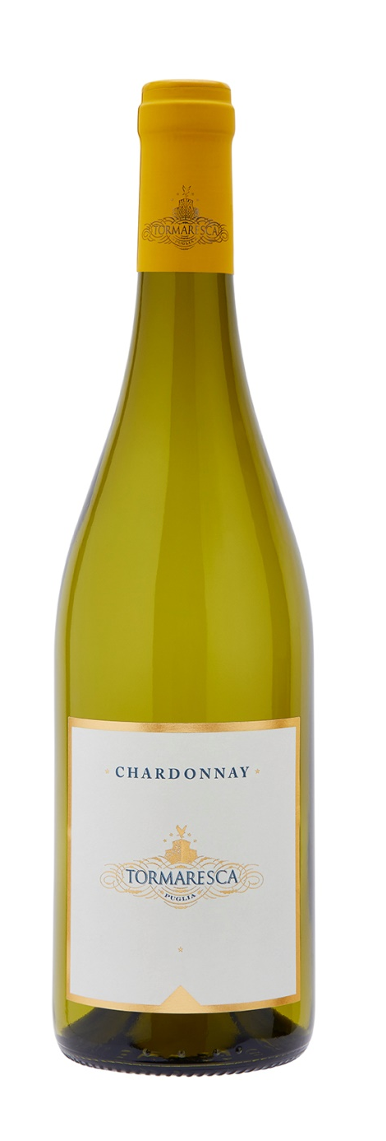
CHARDONNAY

Classification
Chardonnay I.G.T. Puglia

Vintage
2024
Grape variety
Chardonnay
Vinification and aging
Chardonnay grapes were harvested, brought to the cellar and gently crushed. The must was then chilled and kept at a temperature of 10 °C (50 °F) for approximately 24 hours to favor natural clarification. Alcoholic fermentation took place in temperature controlled stainless steel vats at 16 °C (61 °F) to enhance the grapes’ aromatic compounds. Tormaresca Chardonnay was aged in stainless steel up until bottling.

Alcohol content
12.5% by Vol.

Historical data
The Masseria Maìme estate is located in one of the most beautiful areas of Upper Salento not too far from the town of San Pietro Vernotico in the province of Brindisi. The estate extends along the coastline forming a unique countryside of vineyards that lies between woodlands and pine forests stretching out as far as the eye can see until blending into the sea. The most prevalent grape varieties grown here are Negroamaro, Primitivo, Syrah, Fiano and Chardonnay.

Tasting notes
Tormaresca Chardonnay is straw yellow with greenish hues. The nose offers predominant notes of fresh white pulp fruit, especially peaches, mangoes and green apples that are accompanied by floral aromas of broom flowers and jasmine. The palate is fragrant and savory with pleasant freshness.

