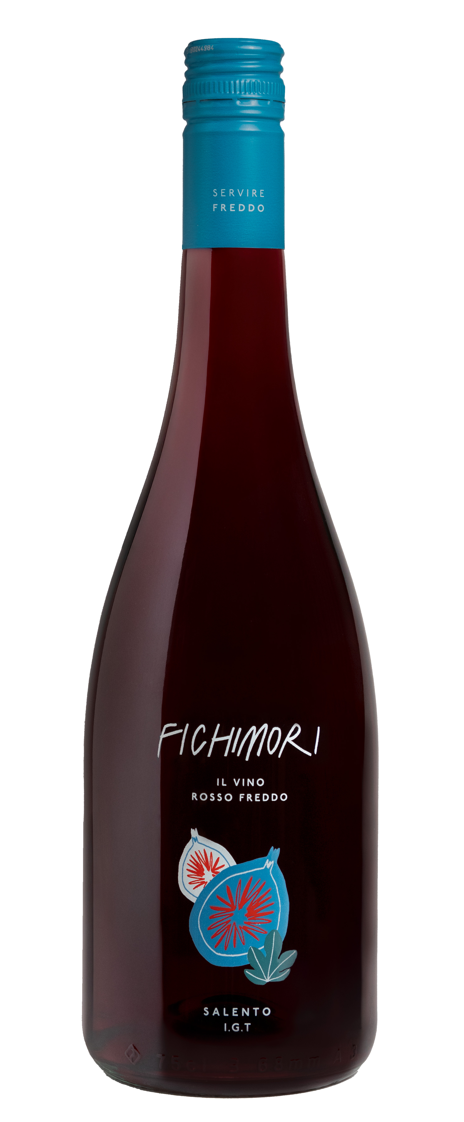
FICHIMORI

Classification
Rosso I.G.T. Salento

Vintage
2024

Grape variety
A selection of grapes grown in the vineyards of the Masseria Maìme estate located in S. Pietro Vernotico

Vinification and aging
Freshly harvested grapes were immediately destemmed and delicately crushed.
The must underwent cold pre-fermentation maceration at a controlled temperature of 5 °C (41 °F) for 5 days to extract the grape variety’s aromas, color, and softest phenolic compounds. The must was then racked, and fermentation took place without the skins at a temperature of 18 °C (64 °F). The wine was aged for several months in stainless steel vats, then bottled and released for sale.

Alcohol content
13% by Vol.

Historical data
The Masseria Maìme estate is located in one of the most beautiful areas of Upper Salento not too far from the town of San Pietro Vernotico in the province of Brindisi. The estate extends along the coastline forming a unique countryside of vineyards that lies between woodlands and pine forests stretching out as far as the eye can see until blending into the sea. The most prevalent grape varieties grown here are Negroamaro, Primitivo, Syrah, Fiano and Chardonnay.
Fichimori is a truly unique wine, a red wine to be served chilled and it is very closely connected to its home territory in Salento, in past eras known as “The Garden of Italy” for the richness and variety of its fruits. This wine owes its name to one of the most delicious fruits native to this area, the fig, and in particular the fig with a reddish-purple color so intense it almost seems black hence its name in local dialect “moro”.

Tasting notes
Fichimori is ruby red with violet hues. Notes of red fruit dominate the nose, especially strawberries and raspberries followed by delicate hints of roses and thyme. The palate is fresh, savory and supple defined by a soft entry and fruity aftertaste.

