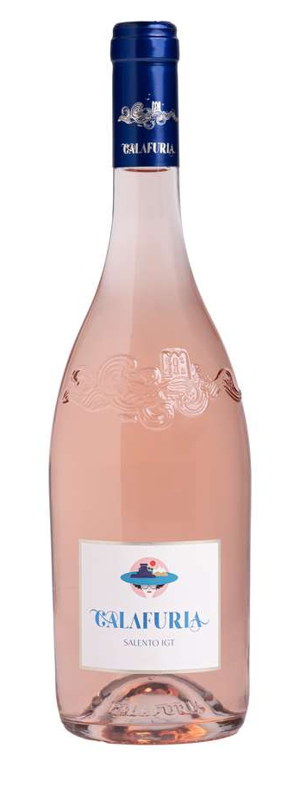
CALAFURIA

Classification
Rosato I.G.T. Salento

Vintage
2024

Climate
2024 began with mild winter weather and average levels of rainfall that replenished good groundwater reservoirs in vineyard soils. The growing season was dry, both in spring and summer. Spring temperatures were consistent with seasonal averages, while summer saw higher temperatures but without any extreme heat events. Breezy condition and the beneficial influence from the Adriatic Sea brought good temperature swings between day and night that helped preserve aromas and freshness of both white and red grape varieties.
Attentive soil management practices together with careful canopy management kept good air circulation around the grapes and avoided overexposure to sunlight, resulting in an optimal balance in vegetative growth and crop load during summer.
Grapes for Calafuria were harvested between August 7th and September 3rd, about two weeks earlier than average of past vintages.

Vinification and aging
Immediately after harvesting, the grapes were destemmed and gently pressed. The must was transferred into temperature controlled stainless steel vats at 12 °C (54 °F) to promote natural clarification of the must. Alcoholic fermentation took place at a temperature of 16 °C (61 °F) to preserve and enhance aromatic compounds. Calafuria was left to age on the lees in stainless steel tanks for a short period of time before it was bottled and released for sale.

Alcohol content
12.5 % by Vol.

Historical data
Masseria Maìme is located in one of the most beautiful areas of Upper Salento not too far from the town of San Pietro Vernotico in the province of Brindisi. The estate extends along the coastline forming a unique countryside of vineyards that lies between woodlands and pine forests stretching out as far as the eye can see until blending into the sea. The most prevalent grape varieties grown here are Negroamaro, Primitivo, Syrah, Cabernet and Chardonnay.
Calafuria is produced from vineyards that extend along the Adriatic coastline. Its name comes from one of the over 700 bays on the Apulian peninsula. The region boasts a long tradition for the production of rosé wines made from Negroamaro, a variety that best expresses its full potential near the sea. Calafuria is a rosé that is delicate, pleasantly fruity, savory, and well-rounded, reflecting the aromas and colors of its home territory, Salento.

Tasting notes
Calafuria 2024 is a delicate dog rose color. The impressive nose offers fruity and citrusy notes of pink grapefruits, pineapples, white peaches together with pleasant floral hints of jasmine and roses. The palate is pleasantly fresh defined by outstanding aromatic persistence and delicate savory notes.

